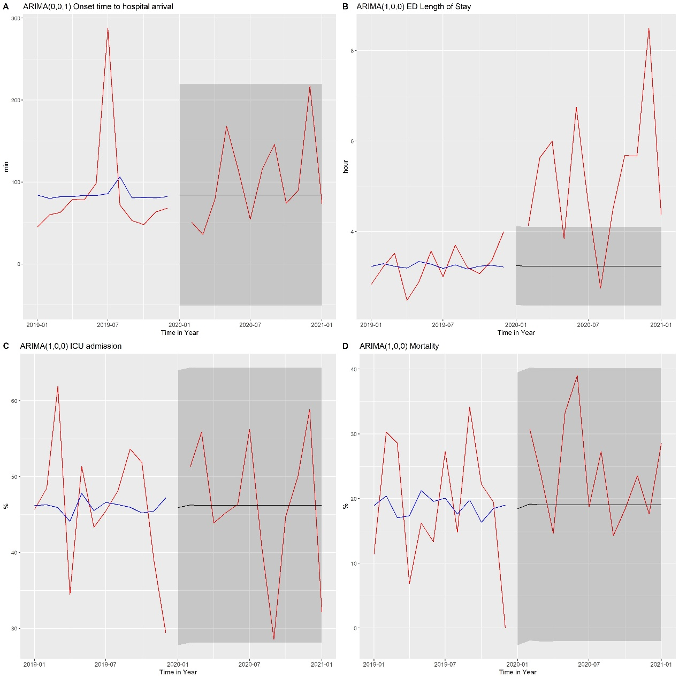
Fig. 1. Time-series analysis of onset time to hospital arrival time and outcomes of patients with hemorrhagic stroke using the ARIMA model. Red line, observed data; blue line, ARIMA model; black line, forecasted value; and shadowed area, 95% confidence interval of the forecasted value. ARIMA, autoregressive integrated moving average.

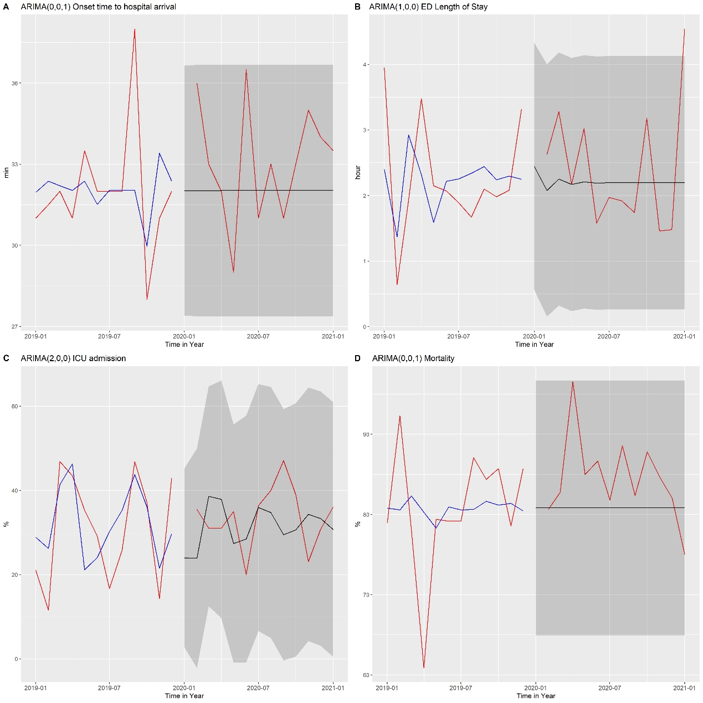
Fig. 2. Time-series analysis of onset time to hospital arrival time and outcomes of patients with cardiac arrest using the ARIMA model. Red line, observed data; blue line, ARIMA model; black line, forecasted value; and shadowed area, 95% confidence interval of the forecasted value. ARIMA, autoregressive integrated moving average

Table 1. Demographic, characteristics, and outcomes of acute myocardial infarction patients.
 | Pre-period  (n=299) | Post-period  (n=376) | p-value
Sex |  |  | 0.638
Female | 56 (18.7%) | 77 (20.5%)
Male | 243 (81.3%) | 299 (79.5%)
Age (years) | 60.0 [53.0-71.0] | 63.0 [56.0-77.0] | 0.002**
EMS use | 164 (54.8%) | 187 (49.7%) | 0.214
Transfer-in | 102 (34.1%) | 101 (27.0%) | 0.056
Mental status |  |  | 0.229
Alert | 273 (91.3%) | 350 (93.1%)
Verbal | 12 (4.0%) | 6 (1.6%)
Painful | 8 (2.7%) | 9 (2.4%)
Unresponsive | 6 (2.0%) | 11 (2.9%)
SBP (mmHg) | 139.0 [120.0-158.5] | 140.0 [119.0-160.0] | 0.678
HR (/min) | 81.0 [68.0-94.0] | 80.0 [66.0-96.0] | 0.506
RR (/min) | 18.0 [16.0-18.0] | 18.0 [16.0-18.0] | 0.534
Onset to hospital arrival time (min) | 143.0 [45.0-481.0] | 123.0 [49.0-475.0] | 0.931
Outcomes
ED length of stay (h) | 5.1 [2.5-9.5] | 6.0 [2.8-11.4] | 0.021*
In-hospital mortality | 24 (8.0%) | 36 (9.6%) | 0.572
ICU admission | 163 (54.5%) | 132 (35.1%) | <0.001***
Ventilator use in ED | 29 (9.7%) | 35 (9.3%) | 0.968
Multivariable linear regression analysis of length of stay in ED
 | Beta-coefficient | 95% CI | P-value
Post-periodª | 0.997 | -0.464-2.457 | 0.181
* p<0.05,** p<0.01,*** p<0.001.
Data are expressed as median [interquartile range] or number (%) as appropriate.
CI, confidence interval; ED, emergency department; EMS, emergency medical service; HR, heart rate; ICU, intensive care unit; RR, respiratory rate; SBP, systolic blood pressureª Adjusted for sex, age, mental status, EMS use, SBP, HR, RR.

Table 2. Demographic, characteristics, and outcomes of ischemic stroke patients.
 | Pre-period  (n=565) | Post-period  (n=566) | p-value
Sex |  |  | 0.524
Female | 217 (38.4%) | 206 (36.4%)
Male | 348 (61.6%) | 360 (63.6%)
Age (years) | 65.0 [54.0-77.0] | 67.0 [57.0-78.0] | 0.021*
EMS use | 238 (42.1%) | 237 (41.9%) | 0.980
Transfer-in | 103 (18.4%) | 107 (18.9%) | 0.874
Mental status |  |  | 0.700
Alert | 474 (83.9%) | 471 (83.2%)
Verbal | 49 (8.7%) | 45 (8.0%)
Painful | 40 (7.1%) | 49 (8.7%)
Unresponsive | 2 (0.4%) | 1 (0.2%)
SBP (mmHg) | 156.0 [137.5-178.0] | 157.0 [141.0-180.0] | 0.164
HR (/min) | 82.0 [70.0-94.0] | 80.0 [70.0-93.0] | 0.270
RR (/min) | 16.0 [16.0-18.0] | 16.0 [16.0-18.0] | 0.417
Onset to hospital arrival time (min) | 246.0 [64.0-1054.0] | 361.5 [67.0-1479.0] | 0.008**
Onset to hospital arrival time within 4.5 h | 305 (54.0%) | 256 (45.2%) | 0.004**
Outcomes
ED length of stay (h) | 3.9 [2.9-5.6] | 4.8 [3.5-7.8] | <0.001***
In-hospital mortality | 28 (5.0%) | 26 (4.6%) | 0.884
ICU admission | 82 (14.5%) | 64 (11.3%) | 0.129
Ventilator use in the ED | 16 (2.8%) | 25 (4.4%) | 0.205
Multivariable linear regression analysis of length of stay in ED
 | Beta-coefficient | 95% CI | P-value
Post-periodª | 2.135 | 1.365-2.904 | <0.001***
* p<0.05,** p<0.01,*** p<0.001
Data are expressed as median [interquartile range] or number (%) as appropriate.
CI, confidence interval; ED, emergency department; EMS, emergency medical service; HR, heart rate; ICU, intensive care unit; RR, respiratory rate; SBP, systolic blood pressure ª Adjusted for sex, age, mental status, EMS use, SBP, HR, RR, ventilator use in ED.
Table 3. Demographic, characteristics, and outcomes of hemorrhagic stroke patients.
 | Pre-period  (n=372) | Post-period  (n=413) | p-value
Sex |  |  | 0.588
Female | 163 (43.8%) | 172 (41.6%)
Male | 209 (56.2%) | 241 (58.4%)
Age (years) | 58.0 [48.0-69.0] | 59.0 [49.0-73.0] | 0.063
EMS use | 271 (72.8%) | 282 (68.3%) | 0.186
Transfer-in | 81 (21.9%) | 126 (30.9%) | 0.006**
Mental status |  |  | 0.191
Alert | 211 (56.7%) | 241 (58.4%)
Verbal | 45 (12.1%) | 35 (8.5%)
Painful | 79 (21.2%) | 104 (25.2%)
Unresponsive | 37 (9.9%) | 33 (8.0%)
SBP (mmHg) | 157.0 [133.0-184.0] | 154.0 [134.0-185.0] | 0.966
HR (/min) | 84.0 [73.0-98.0] | 84.0 [70.0-100.0] | 0.761
RR (/min) | 18.0 [16.0-18.0] | 16.0 [16.0-18.0] | 0.400
Onset to hospital arrival time (min) | 66.0 [34.5-331.5] | 90.0 [36.0-425.0] | 0.130
Outcomes
ED length of stay (h) | 3.3 [2.1-5.2] | 4.8 [3.0-8.8] | <0.001***
In-hospital mortality | 69 (18.5%) | 101 (24.5%) | 0.055
ICU admission | 170 (45.7%) | 193 (46.7%) | 0.827
Ventilator use in ED | 110 (29.6%) | 121 (29.3%) | 0.996
Multivariable linear regression analysis of length of stay in ED
 | Beta-coefficient | 95% CI | P-value
Post-periodª | 2.590 | 1.844-3.335 | <0.001***
* p<0.05,** p<0.01,*** p<0.001.
Data are expressed as median [interquartile range] or number (%) as appropriate.
CI, confidence interval; ED, emergency department; EMS, emergency medical service; HR, heart rate; ICU, intensive care unit; RR, respiratory rate; SBP, systolic blood pressure ^{b} Adjusted for sex, age, mental status, EMS use, SBP, HR, RR.
Table 4. Demographic, characteristics, and outcomes of cardiac arrest patients
 | Pre-period  (n=343) | Post-period  (n=383) | p-value
Sex |  |  | 0.036*
Female | 113 (32.9%) | 156 (40.7%)
Male | 230 (67.1%) | 227 (59.3%)
Age (years) | 61.0 [49.0-75.5] | 64.0 [52.0-79.0] | 0.056
EMS use | 318 (92.7%) | 343 (89.6%) | 0.175
Transfer-in | 51 (15.3%) | 39 (10.5%)
Onset to hospital arrival time (min) | 32.0 [26.0-45.0] | 33.0 [27.0-48.0] | 0.371
Outcomes
ED length of stay (h) | 2.1 [0.9-5.4] | 2.0 [1.1-6.2] | 0.038*
In-hospital mortality | 279 (81.3%) | 323 (84.3%) | 0.332
ICU admission | 110 (32.1%) | 131 (34.2%) | 0.596
Ventilator use in ED | 185 (53.9%) | 194 (50.7%) | 0.418
Multivariable linear regression analysis of length of stay in ED
 | Beta-coefficient | 95% CI | P-value
Post-periodª | 0.665 | -0.098-1.612 | 0.148
* p<0.05,** p<0.01,*** p<0.001
Data are expressed as median [interquartile range] or number (%) as appropriate.
CI, confidence interval; ED, emergency department; EMS, emergency medical service ª Adjusted for sex, age, transfer-in, EMS use, onset to hospital arrival time.

